WEEK-4
Aim : To demonstrate date conversion functions and Constraints
Description :
Date Conversion Functions :
In Oracle, date conversion functions are used to convert between different date formats and data types. These functions are crucial for handling date and time values in various formats, ensuring consistency, and facilitating date-related calculations.
Constraints :
In Oracle, constraints are rules applied to table columns to enforce data integrity and ensure accuracy and reliability of the data stored in the database. They define conditions that data must meet to be inserted or updated in a table. Here are the primary types of constraints in Oracle:
● Not Null
● Unique
● Primary Key
● Foreign Key
● Check
● Default
Date Conversion Functions :
- Query statement : Convert the date '10-11-2004' into sysdate format
Syntax : to_date(string , specified format)
Query : select to_date('10-11-2004','DD-MM-YYYY') from dual
Output :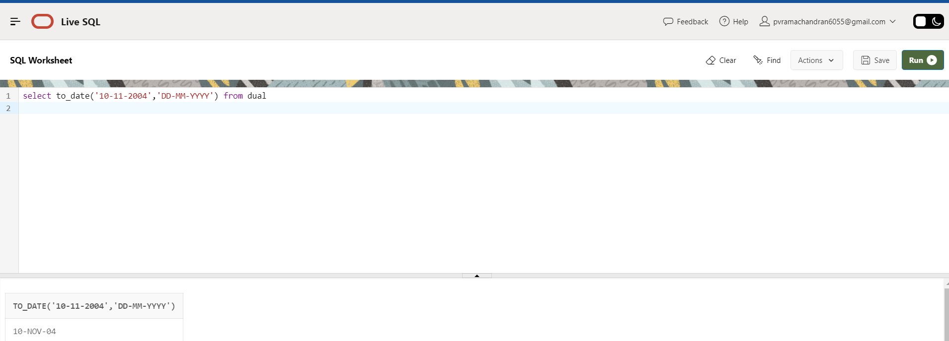

- Query statement : Convert the date '11/10/2004' into sysdate format
Syntax : to_date(string , specified format)
Query : select to_date('11/10/2004','MM/DD/YYYY') from dual
Output :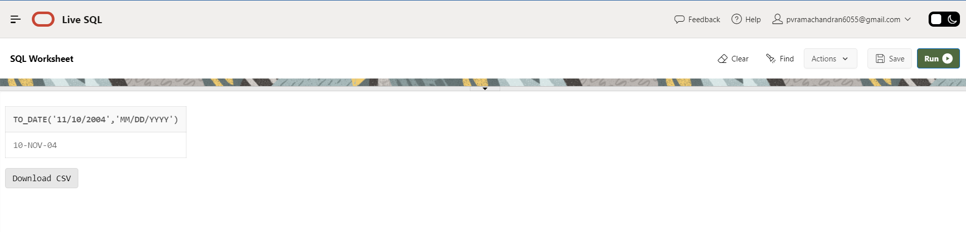
- Query statement : Display the date in the form of 'DD-MM-YYYY'
Syntax : to_char(date , specified format)
Query : select to_char(sysdate,'DD-MM-YYYY') from dual;
Output :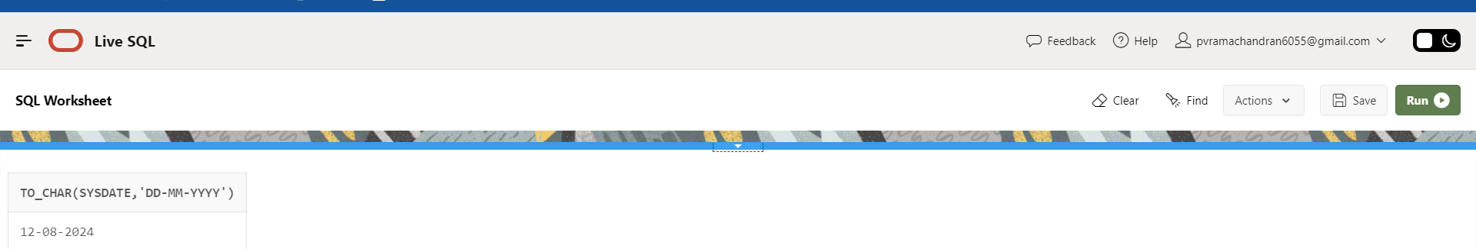

- Query statement : Display the date in the form of 'DD-Mon-YY'
Syntax : to_char(date , specified format)
Query : select to_char(sysdate,'DD-Mon-YY') from dual;
Output :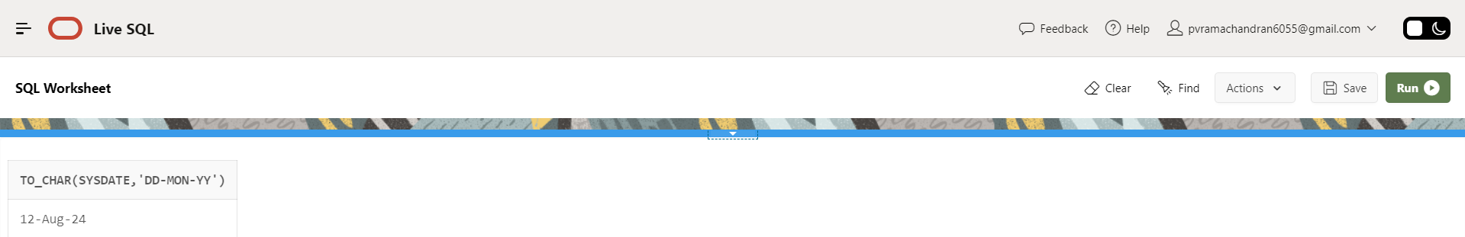

Constraints :
- Query statement : Create a student table using constraints.
Syntax :
● Not Null : column_name datatype NOT NULL
● Unique : column_name datatype UNIQUE
● Primary Key : column_name datatype PRIMARY KEY
● Check : column_name datatype CHECK(Condition)
● Default : column_name datatype DEFAULT default_value
● Foreign Key : FOREIGN KEY (column_name) REFERENCES other_table (column_name)
Query :
create table student(sno number(10) primary key,
sname varchar2(20) not null,
marks number(10) check(marks>60),
email varchar2(30) unique,
city varchar2(5) default 'VZM',
DOB date);
desc student;
Output :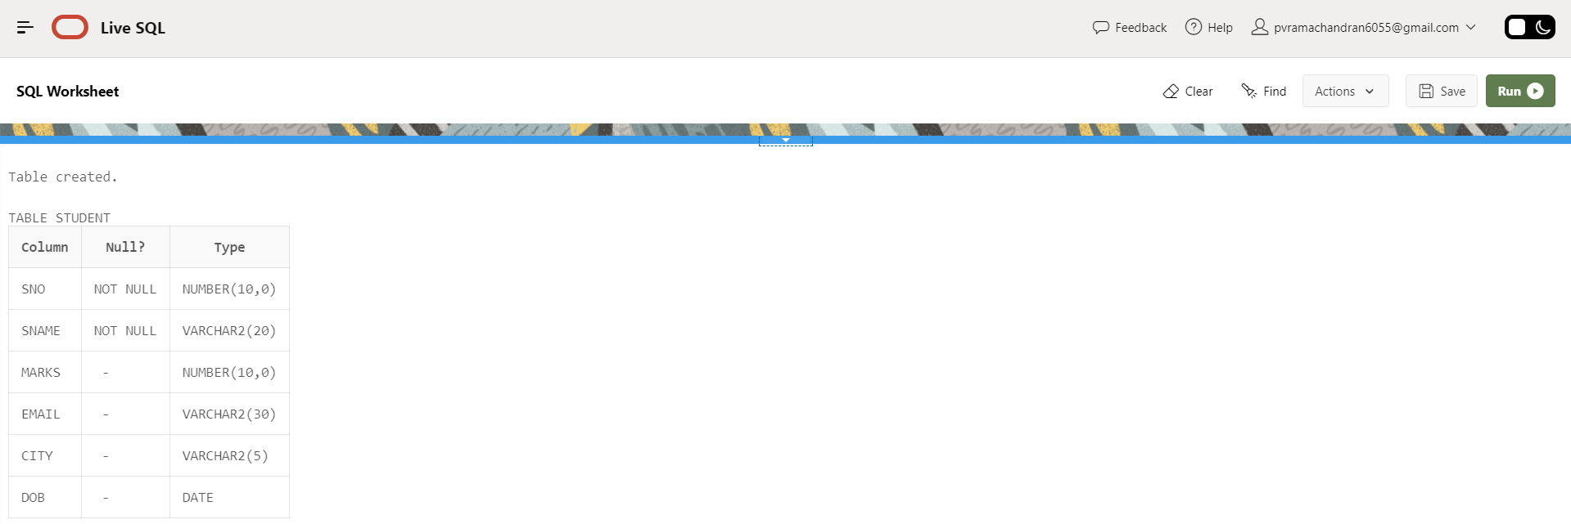
- Query statement : To insert details of students and skipping the column containing not null constraint.
Syntax : insert into <table_name> values(col1,col2,......coln);
Query :insert into student values(101,null,90,'shreek25@gmail.com','VSK','10-NOV-04');
select * from student;
Output : 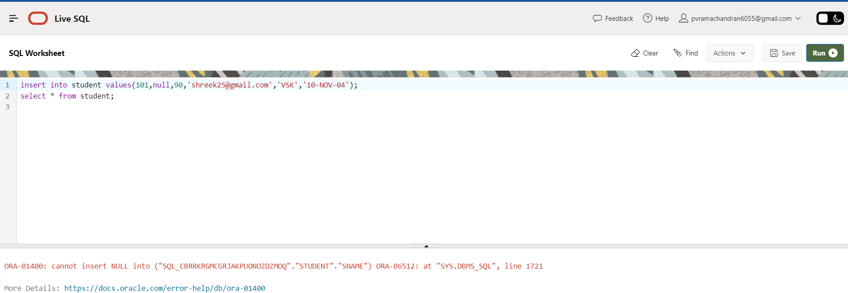
- Query statement : To insert details of students and inserting some duplicate values in the column containing unique constraint

Syntax : insert into <table_name> values(col1,col2,......coln);
Query :insert into student values(101,'Shuba',90,'Shuba@gmail.com','VSK','10-NOV-04');
insert into student values(102,'Sumi',80,'Sumi@gmail.com','VZM','30-NOV-02');
insert into student values(103,'Sreekanth',82,'Sumi@gmail.com','VZM','10-NOV-01');
select * from student;
Output :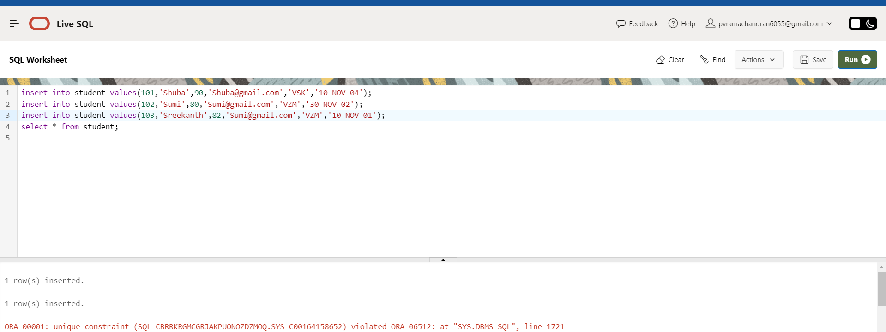

- Query statement : To insert details of students, inserting some duplicate values and null values in the column containing primary key constraint.
Syntax : insert into <table_name> values(col1,col2,......coln);
Query :insert into student values(101,'Shuba',90,'Shuba@gmail.com','VSK','10-NOV-04');
insert into student values(102,'Sumi',80,'Sumi@gmail.com','VZM','30-NOV-02');
Output :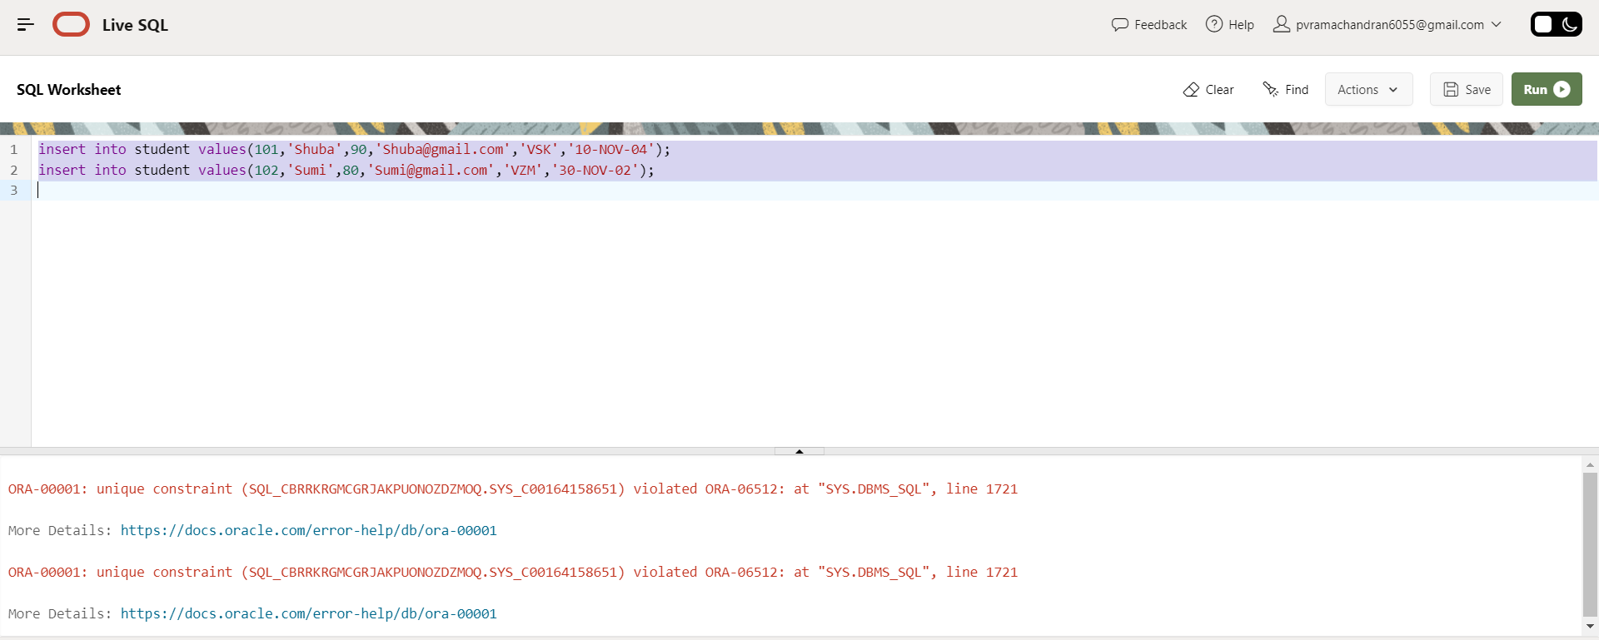
- Query statement : To insert student details and the marks must be greater than 60.
Syntax : insert into <table_name> values(col1,col2,......coln);
Query :
insert into student values(102,'Saiteja',55,'saiteja@gmail.com','VZM','30-NOV-02');
select * from student;
Output :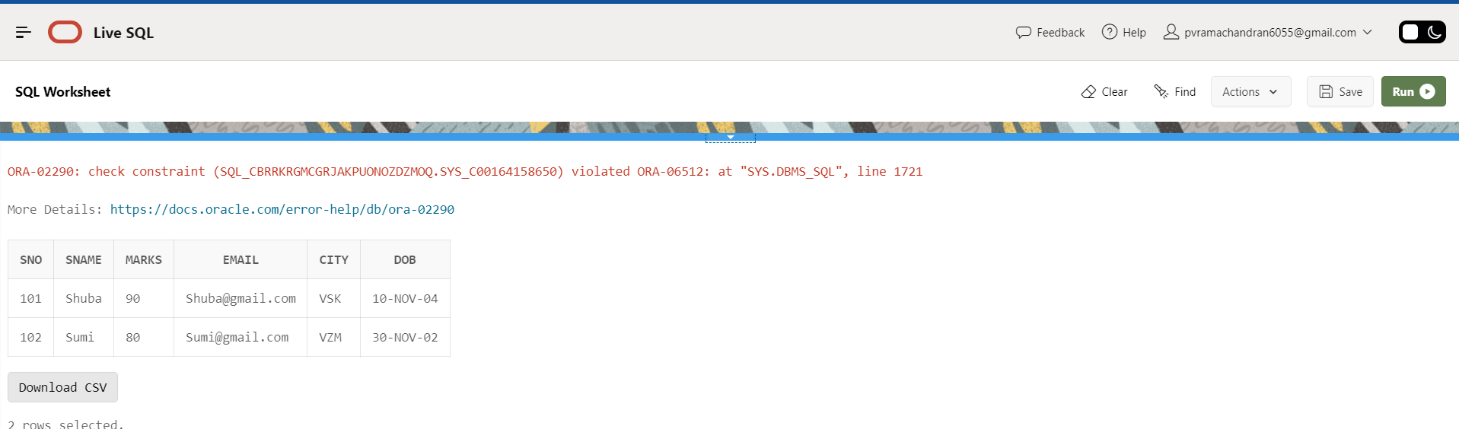
- Query statement : Inserting the details of the student by skipping the column city.
Syntax : insert into <table_name>(col1_name,col2_name,..,coln_name) values(col1,col2,......coln);
Query :
insert into student(sno,sname,marks,email,DOB) values(103,'Abishek',99,'saiteja@gmail.com','05-feb-05');
select * from student;
Output :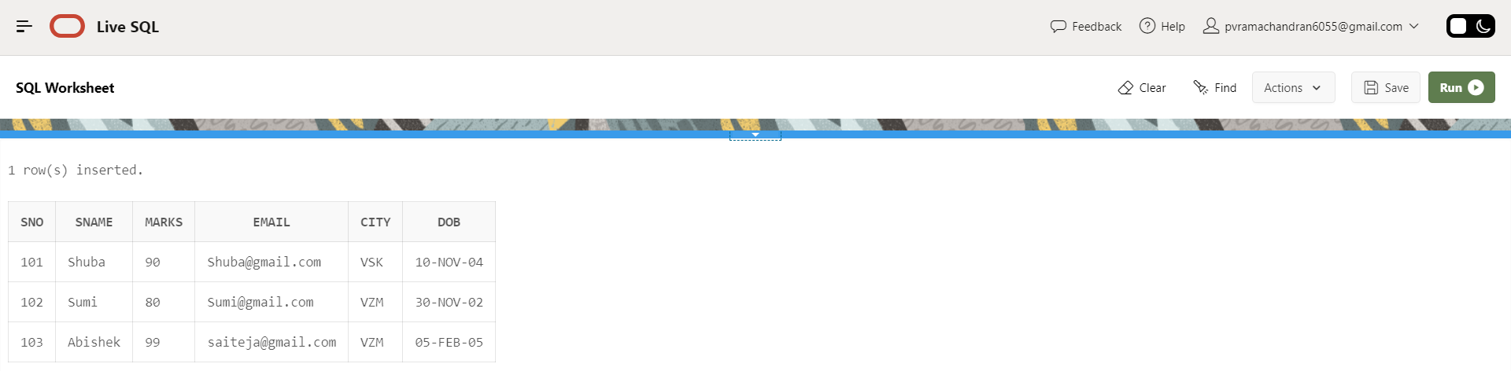
- Query statement : Demonstrate foreign key constraints by creating a course table.
Syntax : FOREIGN KEY (column_name) REFERENCES other_table (column_name)
Query :
CREATE TABLE course (
cid NUMBER(10) PRIMARY KEY,
cname VARCHAR2(20),
sno NUMBER(10),
FOREIGN KEY (sno) REFERENCES student(sno)
);
insert into course values(1010,'cloud computing',101);
insert into course values(1011,'C programming',101);
select * from course;
Output :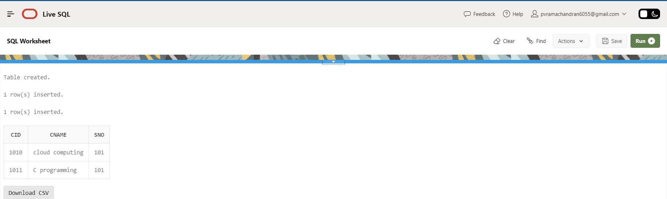

Observations :
● Date conversion functions provide precise and flexible means to convert between string representations and date/timestamp data types. They allow specifying exact formats, which helps in handling various date formats consistently.
● While Oracle provides default format models, explicitly specifying the desired format in date conversion functions is a best practice. This avoids ambiguities and ensures that the date string is interpreted correctly, regardless of session or system defaults.
● Constraints like PRIMARY KEY, UNIQUE, FOREIGN KEY, CHECK, and NOT NULL are essential for maintaining data integrity and consistency within the database. They enforce rules that prevent invalid data from being entered or maintained, ensuring the reliability of the database.
● Constraints can pose challenges during schema evolution, such as adding new columns, altering data types, or modifying relationships.

End of the week :
Signature of the Lab Faculty :
Date :

